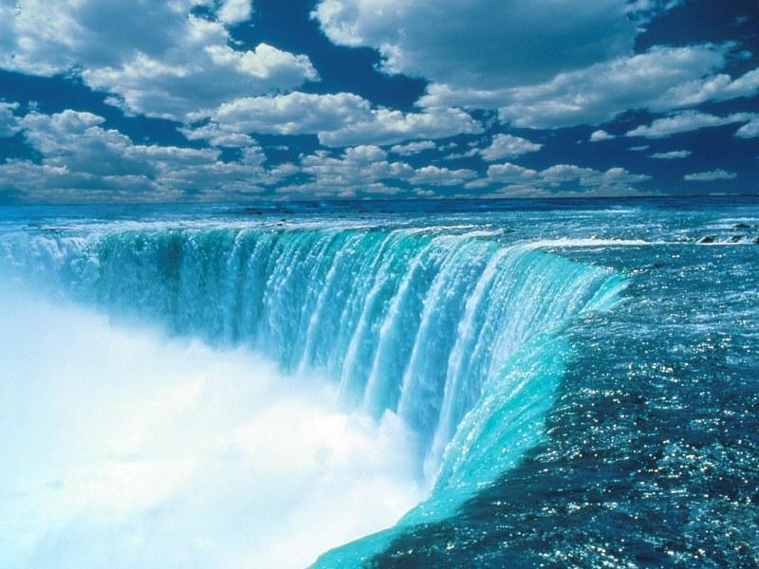
Roger’s Ride to Niagara Falls
35th Year
June 2nd and June 3rd, 2018

You are welcome to join us on this 100 mile cycling adventure, which many of our riders call the best century ride anywhere. Our day will include scenic overlooks of Lake Erie, the wonderful vineyards of winery country and the pure joy of coasting the last mile downhill to our final destination, Niagara Falls.

If this is your first trip with us, you will find the route is very scenic, gently rolling with few hills, and that we break the day’s ride into manageable sections. We want to note that this is still one hundred miles. Riders are encouraged to train prior to the ride to be able to sustain a moderate average pace. For those of you on your second, third or umteenth ride, welcome back. For each of you, we look forward to sharing this part of life’s journey.

Some Details:
- Meet at Gibson Park in North East, Pa., Saturday, June 2nd at 6:23 A.M. We will need to be on the road by 7:01 to preserve daylight.
- Bring some food/goodies to share with the group.
- Helmets are mandatory
- One rule---you may ride as fast as you like to each checkpoint, but must wait until the last rider has a chance to refresh. This is a tour-not a race!
- Bring identification for customs! Passports, Enhanced drivers license or passport cards is required. We would hate to leave you at the border….
- A 12 passenger van and a box truck will be with us for support.
- Meals and room costs are on your own. We coordinate the booking with Michaels Inn By The Falls. Rooms start at $125.00 US and up.
- After breakfast on Sunday, June 3rd, we ride to Niagara-on-the-Lake, a 16-mile, beautiful ride on a bike path beside the Niagara River.
- We normally return to North East by 6 or so Sunday, June 3rd.
- Questions??? Call Roger at 814-724-4850 (office) 814-337-5111 (home) or 814-720-5111 (cell).

We look forward to hearing from you.

Roger

ROGER’S RIDE TO NIAGARA FALLS
Saturday, June 2nd and Sunday, June 3rd , 2018
REGISTRATION

Legal Name on Passport: ______________________________________

Passport Number: ______________________________________

Address _________________________________________________

_________________________________________________

Phone # _________________________________________________
Contact in the Event of an Emergency:
Name: ___________________Phone:_____________________

Roommate (s)-if you are staying with us:_____________________________

Plan on returning to North East with us? Yes or No
Any Special Medical Needs? _____________________________________

ASSUMPTION OF RISK
The undersigned (“Rider”) intends to participate in Roger’s Ride to Niagara Falls, which includes bicycling, travel by vehicle and other activities. The Rider is aware that participation in this event involves risks, hazards and dangers. The Rider is familiar with bicycle safety and will exercise proper bicycle safety throughout the trip, including wearing a bicycle helmet while riding.

RELEASE AND WAIVER OF LIABILITY AND INDEMNIFICATION AGREEMENT

The Rider understands that accidents, injuries, and even death can occur during this event. In recognition of the Rider’s understanding of these risks, the Rider, by signing this Release does release and agree to hold harmless the organizer, Roger Janes, his family and all volunteers for this event free from any and all action and actions, and cause and causes of action and actions and all claims and demands whatsoever in law or equity, which the Rider may have on account of or arising out of participation by the Rider in Roger’s Ride to Niagara Falls, including personal or bodily injury and/or loss or damage to personal property.

The Rider understands that signing this Release is a condition for participation by the Rider in Roger’s Ride to Niagara Falls.

Date: ___________________________________________________

Agreed by: _______________________________________________
Rider (s)

The rider’s contribution is $85.00 per person, non-refundable after May 1st, 2018. Please make your check payable to: Roger Janes, 15393 West Grandview, Meadville, PA 16335

